**INSTITUTE OF ENGINEERING**

ADVANCED COLLEGE OF ENGINEERING AND MANAGEMENT

Kupondole, Lalitpur

**(AFFILIATED TO TRIBHUVAN UNIVERSITY)**



Lab No:3

Subject: Simulation And Modeling

**Submitted By: Submitted To:**

Department of Computer

and

Electronics Engineering

Name: Sameep Dhakal

Roll no: ACE074BCT063

Date: 2/28/2022

# LAB 3 – PI SIMULATION

## Objective:

Generate coordinates of circle using pi simulation

## Theory:

Monte Carlo estimation

Monte Carlo methods are a broad class of computational algorithms that rely on repeated random sampling to obtain numerical results. One of the basic examples of getting started with the Monte Carlo algorithm is the estimation of Pi.

Estimation of Pi

The idea is to simulate random (x, y) points in a 2-D plane with domain as a square of side 1 unit. Imagine a circle inside the same domain with same diameter and inscribed into the square. We then calculate the ratio of number points that lied inside the circle and total number of generated points.

## Source code:

#include<stdio.h>

#include<conio.h>

#include<math.h>

#include<stdlib.h>

void main()

{

double i,seed=20000,x,y,xc,yc,h=0,pi;

FILE *f;

//clrscr();

f = fopen("newoutputpi.txt","w");

srand(seed);

fprintf(f,"i\tPI\tXC\tYC\n");

for(i=1;i<=10000;i++)

{

x=(double)rand()/RAND_MAX;

y=(double)rand()/RAND_MAX;

if((pow(x,2)+pow(y,2))<=1)

{

h++;

xc=x;

yc=y;

}

else

{

xc=0;

yc=0;

}

pi = (double)4*h/i;

fprintf(f,"%e\t%e\t%e\t%e\n",i,pi,xc,yc);

}

fclose(f);

printf("\npi=%f",pi);

getch();

}

## Output:

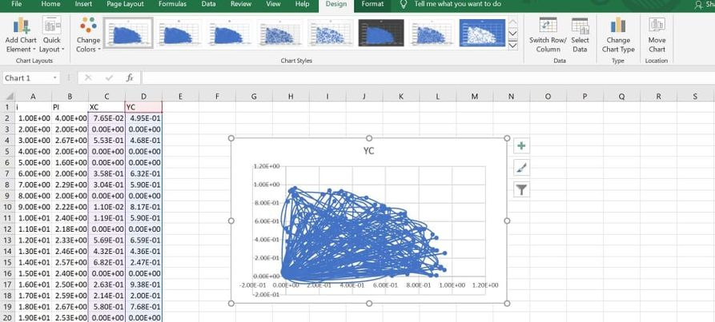

## Discussion and conclusion:

In this lab we plotted generated value of pi as 3.14 and also generated coordinated of circles to visualize them in the excel file using scatter plot.